**A**

**PROJECT REPORT**

**ON**

***“Dairy Farm and Milk Supply Management System”***

SUBMITTED BY:

**Siddhesh Vilas Jadhav**

**PRN No. :** *2124UCEM1100*

**SUBJECT:**

*Programming and problem solving using c++*

**Under the guidance of**

*Miss. Ishwari Tirse*



***Department of Computer Science and Engineering***

***Sanjivani Rural Education Society’s***

***SANJIVANI UNIVERSITY***

***KOPARGAON – 423603, DIST : AHMEDNAGAR***

***2024-2025***

**INDEX**

|  |  |  |
| --- | --- | --- |
| **SR.**  **NO** | **CONTENT** | **PAGE NO.** |
| **1.** | **INTRODUCTION** | **3** |
| **2.** | **CODE** | **4** |
| **3.** | **OUTPUT** | **8** |
| **4.** | **CONCLUSION** | **10** |

**INTRODUCTION**

A Dairy Farm and Milk Supply Management System helps farmers and suppliers efficiently manage milk production, track inventory, and handle customer deliveries. The system keeps records of cow details, milk production data, and supply schedules to ensure smooth operation and timely deliveries.

**Code**

#include <iostream>

#include <vector>

#include <string>

class Animal {

std::string id;

double dailyProduction;

// Additional attributes like health status

public:

Animal(std::string id, double production) : id(id), dailyProduction(production) {}

double getProduction() const { return dailyProduction; }

void displayInfo() const {

std::cout << "Animal ID: " << id << ", Daily Production: " << dailyProduction << " liters\n";

}

};

class Inventory {

double totalMilk;

public:

Inventory() : totalMilk(0) {}

void addMilk(double amount) { totalMilk += amount; }

void useMilk(double amount) {

if (amount <= totalMilk) totalMilk -= amount;

else std::cout << "Not enough milk in inventory.\n";

}

double getMilk() const { return totalMilk; }

};

class Order {

std::string distributor;

double quantity;

bool isFulfilled;

public:

Order(std::string distributor, double quantity) : distributor(distributor), quantity(quantity), isFulfilled(false) {}

void fulfillOrder() { isFulfilled = true; }

void displayOrder() const {

std::cout << "Distributor: " << distributor << ", Quantity: " << quantity << " liters, Fulfilled: " << (isFulfilled ? "Yes" : "No") << "\n";

}

};

int main() {

Inventory inventory;

inventory.addMilk(500); // Example milk addition

Order order1("Distributor A", 200);

order1.displayOrder();

if (inventory.getMilk() >= 200) {

inventory.useMilk(200);

order1.fulfillOrder();

}

std::cout << "Remaining milk in inventory: " << inventory.getMilk() << " liters\n";

    return 0;

}

**OUTPUT**

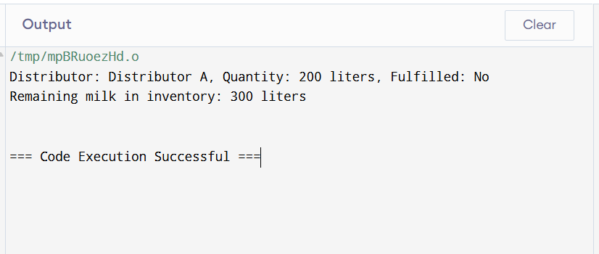

**CONCLUSION**

This Dairy Farm and Milk Supply Management System efficiently manages cows and milk supply operations. By tracking each cow’s milk production and monitoring the overall inventory, the system helps ensure customers receive their orders accurately. This prototype can be extended to incorporate additional functionalities like quality tracking, pricing, and supply schedules.